**Final SRS Report**

**Submitted by : Group 5 Anish Thapaliya K200971**

**Krishna Bhusal K200265**

**Submitted To : Professor Syed**

# 



Contents

1

1. System Requirement Traceability 3

1.1 Functional Requirement 3

1.2 Non-Functional Requirement 4

2. System Architecture: 4

2.1 System Overview 4

2.2. System Architecture Overview: 5

2.3 Hardware Components: 6

2.4 Software Components: 7

2.4.1 Software for HTML development: 7

2.4.2 Drawing tools for editing images: 7

2.4.3 Webserver and Database used for Application: 7

2.4.4 Software used for scripting and run query: 8

2.4.5 Logical View of the System: 8

2.4.6 Functional View of the system by components: 8

3. Database Design: 9

3.1 Revised ERD 9

3.3 Database design 9

4. User Interface design: 9

# 1. System Requirement Traceability

## 1.1 Functional Requirement

|  |  |  |  |
| --- | --- | --- | --- |
| **FR Number** | **Functional requirements** | **Components** | **comments** |
| FR1 | Login | Login.php | Students/Admins will use the login panel to login to their accounts and start required actions. |
| FR2 | User Registration | Registration.php | Registration feature includes new user registration/ registration forms for Unit Enrollments |
| FR3 | Student Enrollment | Enrollment.php | Falls under registration but this use case dictates the Specific Enrollment process for Enrolling on subjects. |
| FR4 | Payments | Payments.php | Students and guardians can make payments for their enrolled units via this function. |
| FR5 | Unit Selection | Unit.php | For selecting the course. Respective course according to respective field of studies can be chosen here. |
| FR6 | Social media page access | Social media .php | Consumers can visit the institute’s social sites via the webpage. |
| FR7 | Data displayed for admins | Adminsdata.php | Feature includes access of Registration data for the admins. |
| FR8 | Clearance level | Clearence.php | Feature adds clearance level between admins and students. Only admins are allowed to view the registration data. |

|  |  |  |  |
| --- | --- | --- | --- |
| FR9 | Feedback and reviews | Feedback/review.php | Students and parents will be allowed to review and provide feedback to the admins. |
| FR10 | Contact Information | Contact.php | A page with Contact information for students and guardians that are looking forward to joining the campus. |
| FR11 | Training manual | Manual.php | Admins and students alike will receive Training manuals for easy navigation. |
| FR12 | Assigning Student ID | StudentID.php | Features enables Admins to Assign student id. |
| FR13 | Different browser Integration | Browser.php | For usability via multiple Bowsers. |
| FR14 | Improved UI | ImprovedUI.php | Modern type design for the UI, Intricate looking yet simple helps new student perform task with ease. |
| FR15 | Enquiry | Enquiry.php | Students can make enquires by submitting their questions to respective departments. |

## 1.2 Non-Functional Requirement

|  |  |  |  |
| --- | --- | --- | --- |
| **Requirement ID** | **NFRs** | **Components** | **Comment** |
| NFR1 | Security | MD5 | MD5 security is being implemented to detect data corruption, but is primarily intended to work effectively while data transmission. |
| NFR2 | Scalability | Bigger Database | As we are using OSS, it is expected to be scalable for more than 1000 users (if required) |
| NFR3 | Availability |  | It should be available to all the user, including stakeholders. |
| NFR4 | Usability |  | The system should be easy to use and provide rich experience to the user, while standard template can also plays significant role. |
| NFR5 | Performance |  | Browsing time, loading time & update time must be smooth & effective. |
| NFR6 | Reliability |  | The website must be reliable & trustworthy. In other word, students must feel safe & secure visit the site & share personal information. |
| NFR7 | Accessibility |  | Accessible to all existing web browser & must provide same experience in any kind. |

# 2. System Architecture:

# 2.1 System Overview

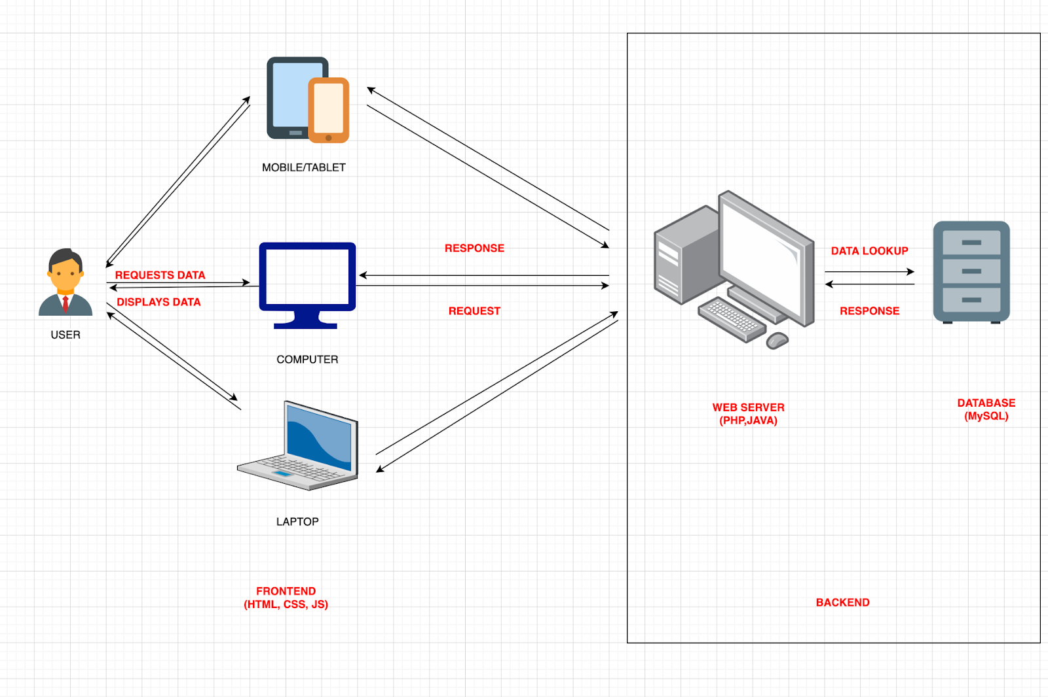

Fig: System Overview for the proposed system. The users in this diagram represent both the admins and the normal consumers. Both these entities will be sending and receiving the data packets from the database via an internet connection. Multiplatform also represents various browser integration and multi-OS integration.

## 2.2. System Architecture Overview:

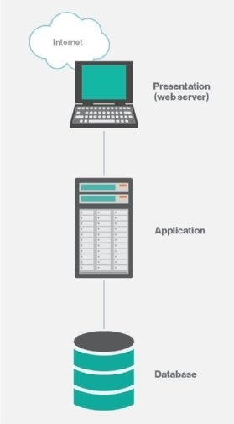

The system architecture is the model that conceptually specifies the system's perspectives, structure, and behavior. In other terms, system architecture is the representation and description of how a system functions and connects with other system components in general.

The main advantage of three-tier design is the logical and physical separation of functions. Each tier can run on a different operating system and server platform, such as a web server, application server, or database server, depending on its functional needs. Furthermore, each tier operates on at least one dedicated server hardware or virtual server, allowing each layer's services to be changed and optimized without affecting the other tiers.

## 2.3 Hardware Components:

Computer hardware is a collective term for any of the physical components of a digital or analogue computer. The word hardware divides the physical parts of a computer system from software, which consists of written, machine-readable instructions or programs that tell physical components what to do and when to do it.

Computer hardware is classified as either internal or external components. Internal hardware components are those required for the computer to work properly, whilst external hardware components are those attached to the computer to add or enhance functionality.

Some Hardware components for users:

* System: Multimedia PC
* Processor: Pentium 4 or above
* Memory: 512 MB RAM
* Hard Disk: 80GB or above
* Keyboard: 104 Standards
* Monitor: SVGA

For Developers:

* System: Multimedia PC
* Processor: Intel core i7 or Above
* Memory: 32 GB RAM
* Hard Disk: 5TB SSD
* Keyboard: 104 Standard
* Monitor: SVGA

## 2.4 Software Components:

* Front end : PHP, HTML, CSS, JavaScript
* Back end : MYSQL
* Operating System : Windows ,LINUX

### 2.4.1 Software for HTML development:

Here in this project we are using Visual Studio Code as a software for HTML development. Well, Visual Studio Code is a simplified code editor that supports development tasks such as debugging, task execution, and version control. It seeks to give only the tools required for a speedy code-build-debug cycle, leaving more complicated processes to full-featured IDEs like Visual Studio IDE.

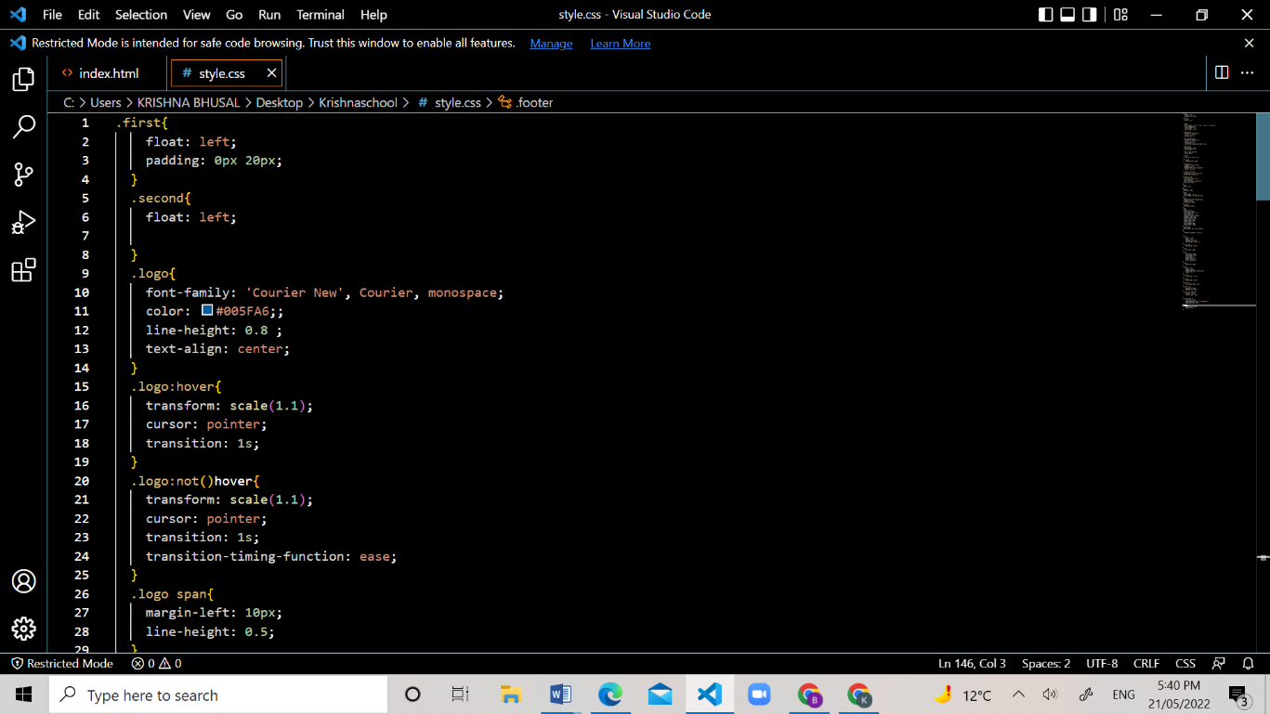

Figure: Visual Studio Coding Style

### 2.4.2 Drawing tools for editing images:

We have actually got data’s & information from KENT website, therefore we didn’t require any drawing tool for editing images, however we have used paint & draw.io to create ERD and so on.

### 2.4.3 Webserver and Database used for Application:

We are using PHP as a webserver. PHP (Hypertext Pre-processor) is a programming language that can be used to create dynamic and interactive webpages. It was one of the first server-side languages that could be embedded in HTML, making it easy to add functionality to web sites without requiring data from other files.

Furthermore, the main task we been performing through PHP is back end server side scripting. PHP allows us to do more than just generate HTML. PHP's capabilities include the ability to produce pictures, PDF files, and even flash movies (through libswf and Ming). You may also quickly print any text, including XHTML and other XML files. Instead of publishing these files, PHP may autogenerate them and save them in the file system, establishing a server-side cache for your dynamic content.

Also, we are using MySQL as our database. MySQL is a relational database management system that is built on SQL (Structured Query Language). The programme is used for a variety of tasks, including data warehousing, e-commerce, and logging. However, the most prevalent application for MySQL is as an online database. It may hold anything from a single piece of information to a whole inventory of items for an online business.

It is possible to develop websites that interact in real-time with a MySQL database to quickly show classified and searchable information to a website user using a scripting language such as PHP or Perl (both of which are available on our hosting accounts).

### 2.4.4 Software used for scripting and run query:

We used MySQL as a scripting language and the scripting was done on phpmyadmin. The description has been written in 2.4.2

### 2.4.5 Logical View of the System:

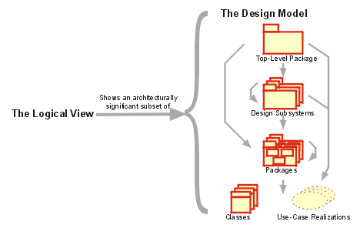

### 2.4.6 Functional View of the system by components:

# 3. Database Design:

## 3.1 Revised ERD

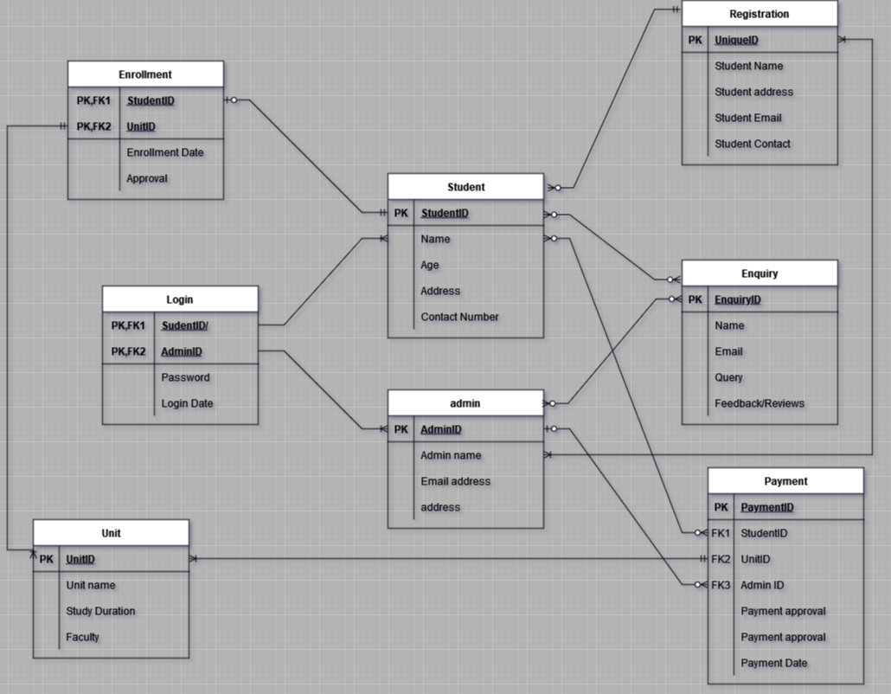

## 3.3 Database design

Here is a screenshot of the php myadmin where we created our database.

Each row represents a table with the respective name.

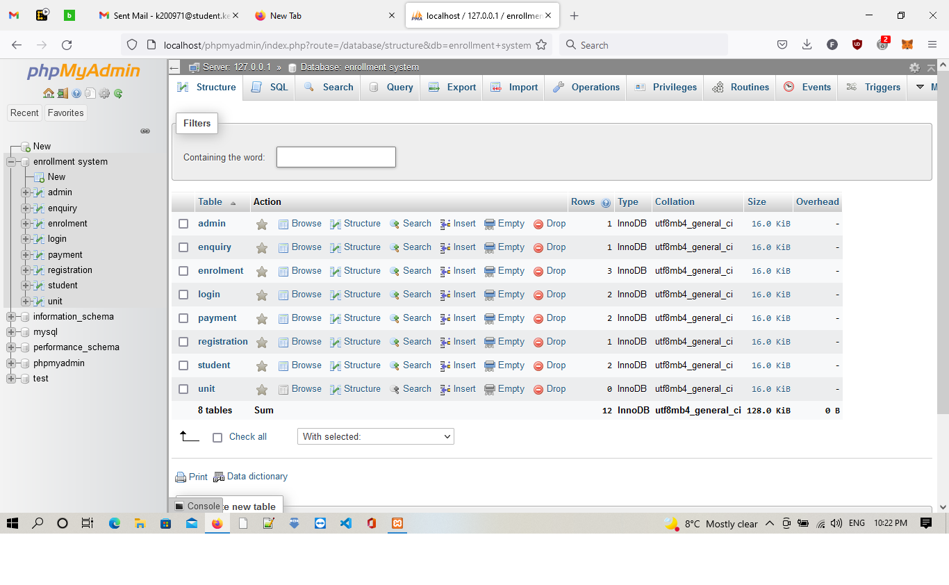

# 4. User Interface design:

Among our 15 different use cases we have some of the use cases co-incident on the same pages as the other. Here is the screenshot of how the landing/login pages will look like. Along with the respective html/css code.

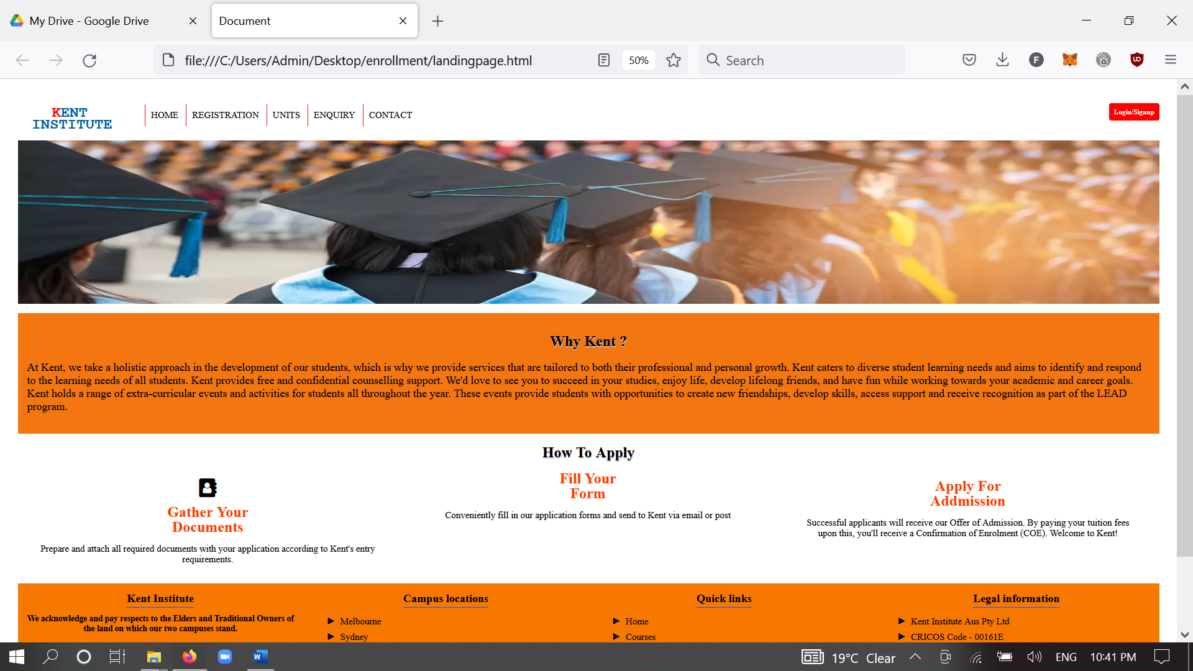

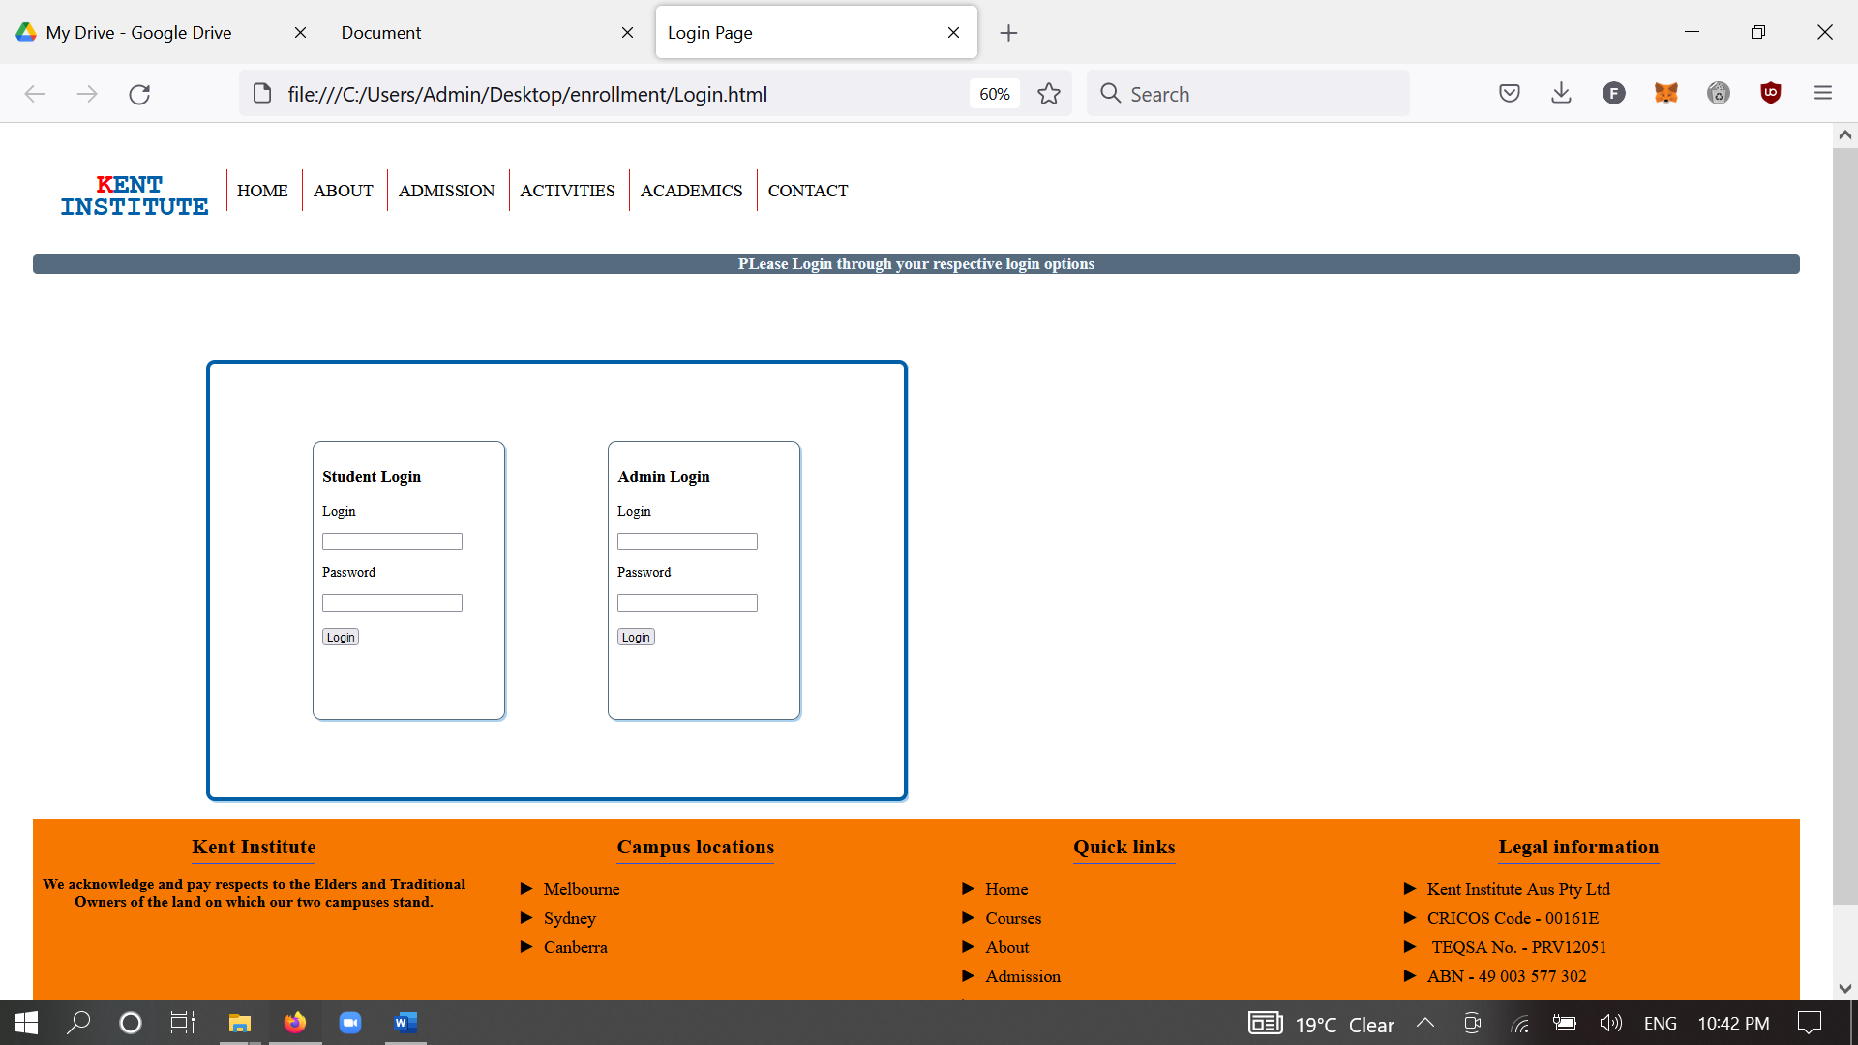

**Landing page**

<!DOCTYPE html>

<html lang="en">

<head>

    <meta charset="UTF-8">

    <meta http-equiv="X-UA-Compatible" content="IE=edge">

    <meta name="viewport" content="width=device-width, initial-scale=1.0">

    <link rel="stylesheet" href="https://cdnjs.cloudflare.com/ajax/libs/font-awesome/4.7.0/css/font-awesome.min.css">

    <script src='https://kit.fontawesome.com/a076d05399.js' crossorigin='anonymous'></script>

    <link rel="stylesheet" href="style.css">

    <title>Document</title>

</head>

<body>

    <div class = "header">

   <div class="first">

      <h1 class="logo">KENT

        <br> <span>INSTITUTE</span>

        </h1>

   </div>

   <div class="second">

     <ul class="order" style="float: left;">

       <li> <a href="landingpage.html">HOME</a></li>

       <li> <a href="register.html">Registration</a></li>

       <li> <a href="#"> Units</a></li>

       <li> <a href="#"> Enquiry </a></li>

              <li><a href="#">Contact</a></li>

      </ul>

     <a href ="Login.html" target="_blank" class="app">Login/Signup</a>

    </div>

    </div>

   <div class="slideshowpictures">

     <img  class="mySlides" src="./images/slideshow2.jpg"  class="banner" style="width: 100%; height: 350px;">

     <img class="mySlides" src="./images/slideshow4.jpg" class="banner" style="width:100%; height:350px;">

     <img class="mySlides" src="./images/slideshow5.jpg" class="banner" style="width:100%; height:350px;">

   </div>

   <script>

    var myIndex = 0;

    carousel();

    function carousel() {

      var i;

      var x = document.getElementsByClassName("mySlides");

      for (i = 0; i < x.length; i++) {

        x[i].style.display = "none";

      }

      myIndex++;

      if (myIndex > x.length) {myIndex = 1}

      x[myIndex-1].style.display = "block";

      setTimeout(carousel, 3000); // Change image every 2 seconds

    }

    </script>

    <!--the code for landing page begins here-->

   <div class="bad">

     <h1 class="head">Why Kent ?</h1>

     <p class="content">

At Kent, we take a holistic approach in the development of our students, which is why we provide services that are tailored to both their professional and personal growth.

Kent caters to diverse student learning needs and aims to identify and respond to the learning needs of all students. Kent provides free and confidential counselling support.

We'd love to see you to succeed in your studies, enjoy life, develop lifelong friends, and have fun while working towards your academic and career goals.

Kent holds a range of extra-curricular events and activities for students all throughout the year. These events provide students with opportunities to create new friendships, develop skills, access support and receive recognition as part of the LEAD program.

     </p>

   </div>

   <div class="">

     <h1 class="head">How To Apply</h1>

     <div class="col">

       <div>

         <p><i class="fa fa-address-book icn" ></i></p>

         <p class="set">Gather Your <br> Documents</p>

         <p class="set1">

          Prepare and attach all required documents with your application according to Kent's entry requirements.

        </p>

       </div>

     </div>

     <div class="col">

      <div>

        <i class="fas fa-book-open icn"></i>

        <p class="set">Fill Your <br> Form</p>

        <p class="set1">

          Conveniently fill in our application forms and send to Kent via email or post

        </p>

      </div>

    </div>

     <div class="col">

      <div>

        <p><i class="fas fa-book-open icn" ></i></p>

        <p class="set">Apply For <br> Addmission</p>

        <p class="set1">

          Successful applicants will receive our Offer of Admission.

          By paying your tuition fees upon this, you'll receive a Confirmation of Enrolment (COE). Welcome to Kent!

        </p>

      </div>

    </div>

  </div>

   <!--the footer section starts here-->

   <div class="footer">

     <div class="cols">

       <h3><span>Kent Institute</span></h3>

       <p style="padding: 0px 10px; font-size:18px"><b>We acknowledge and pay respects to the Elders

         and Traditional Owners of the land on which our two campuses stand.</b></p>

     </div>

     <div class="cols">

       <h3><span>Campus locations</span></h3>

       <ul>

         <li></i>Melbourne</li>

         <li>Sydney</li>

         <li>Canberra</li>

       </ul>

     </div>

     <div class="cols">

      <h3 style="margin-left: -30px"><span>Quick links </span></h3>

      <ul>

        <li>Home</li>

        <li>Courses</li>

        <li>About</li>

        <li>Admission</li>

        <li>Contact us</li>

      </ul>

     </div>

     <div class="cols">

       <h3><span>Legal information</span></h3>

       <ul>

        <li>Kent Institute Aus Pty Ltd

        </li>

        <li>CRICOS Code - 00161E

        </li>

        <li> TEQSA No. - PRV12051</li>

        <li>ABN - 49 003 577 302

        </li>

      </ul>

     </div>

   </div>

</body>

</html>

**Style:**

.first{

    float: left;

    padding: 0px 20px;

  }

  .second{

    float:auto;

  }

  .logo{

    font-family: 'Courier New', Courier, monospace;

    color: #005FA6;;

    line-height: 0.8 ;

    text-align: center;

  }

  .logo:hover{

    transform: scale(0.9);

    cursor: pointer;

    transition: 2s;

  }

  .logo:not()hover{

    transform: scale(1.8);

    cursor: pointer;

    transition: 1s;

    transition-timing-function: ease;

  }

  .logo span{

    margin-left: 10px;

    line-height: 0.5;

  }

  .logo::first-letter{

    color: red;

  }

  .order{

    list-style-type: none;

  }

  ul.order{

      margin-left: 10px;

      }

  ul.order li{

    display: inline-block;

    padding: 12px;

    border-left: 2px solid rgb(218, 19, 19);

    cursor: pointer;

  }

  ul.order li:hover{

   border-left: 2px solid rgb(55, 0, 255);

   transform: scale(1.1);

  }

 ul.order li a{

   text-decoration: none;

   text-indent: 2cm;

   color: black;

   text-transform: uppercase;

   font-size: 20px;

 }

 .slideshowpictures {

  clear: both;

 }

 body{

   padding: 30px;

 }

 .head{

   text-align: center;

   text-shadow: 1px 2px rgb(197, 196, 218);

 }

 .bad{

   background-color: rgb(243, 118, 17);

   padding: 20px;

   margin-top: 20px;

   text-decoration: none;

 }

 .content{

   font-size: 24px;

 }

 .app{

   float: right;

   font-size: 15px;

   text-decoration: none;

   color: rgb(21, 116, 12);

   background-color: red;

   padding: 10px 10px;

   border-radius: 5px;

   margin-top: 14px;

   margin-left: 5px;

   color: white;

   font-weight: 600;

   margin-left: 20px;

 }

 .app:hover{

   box-shadow: 5px 5px 2px gray;

 }

 *{

    border-collapse: collapse;

 }

 .myslides{

   display: none;

 }

 .col{

     width: 33.3%;

     float: left;

     padding: 0px 40px;

     box-sizing: border-box;

 }

 .col div p{

     text-align: center;

 }

 .icn{

     font-size: 40px;

 }

 .set{

     font-size: 32px;

     font-weight: 700;

     line-height: 1;

     margin-top: 0;

     margin-bottom: 0;

     color: #fd3e00;

 }

 .set1{

     font-size: 20px;

 }

 /*the footer starts from here*/

 .cols{

     width: 25%;

     height: 300px;

     background-color: rgb(247, 120, 1);

     float: left;

 }

 .cols h3 {

     text-align: center;

 }

 .cols p{

     text-align: center;

 }

 .cols ul {

     list-style-type: none;

 }

 .cols ul li{

     font-size: 20px;

     padding: 5px 10px;

 }

 .cols ul li::before{

     content:'\25BA';

     margin-right: 10px;

 }

 .cols h3 span {

     font-size: 24px;

     border-bottom: 2px solid #2853e2 ;

     padding-bottom: 5px;

 }

 .footer{

   border-collapse: collapse;

     padding-top: 20px;

     clear: both;

 }

 /*styling for contacts page*/

 .map{

   float: none;

   margin-top: 50px;

 }

 .location{

   float:right;

 }

/*Styling for query page*/

.querybox{

  align-content: space-around;

  justify-content: space-between;

  align-items: center;

  padding: 30px;

}

.querybox input{

justify-content: space-between;

}

/* Styling for login page*/

.topheader{

  text-align: center;

  margin-top: 50px;

  background-color: #566c7e;

  color: aliceblue;

  border-radius: 5px;

}

.loginbox{

  margin-left: 200px;

  align-content: center;

  height: 500px;

  width: 800px;

  border: 5px solid #005FA6;

  margin-top: 100px;

 display:flex;

 align-items: center;

 justify-content:space-evenly;

 border-radius:10px;

 box-shadow: 2px 2px #add2ee;

}

.Lbox{

  height:300px;

  width: 200px;

border:2px solid #566c7e;

padding: 10px;

align-items: center;

border-radius:10px;

 box-shadow: 2px 2px #add2ee;

}

.Rbox{

  height:300px;

  width:200px;

  padding: 10px;

  border:2px solid #566c7e;

  padding: 10px;

  align-items: center;

  border-radius:10px;

 box-shadow: 2px 2px #add2ee;

  }